## 

## 

**Experiment 1:**

**Using Software Tools and Code Versioning System**

CPE106L (Software Design Laboratory)

**Rommel John H. Ronduen**

**Jan Adrian C. Manzanero**

**Mico Kent P. Malatag**

Group No.: **6**

Section: **B1**

## **PreLab**



|  |
| --- |
| GitHub is a platform that has been in my radar for long as a computer engineering student. Many times I have tried to let myself be educated by the ways of version control systems but I always find myself in a wall of learning because I seldom do any projects on the side. Through this endeavor done in the course, I was revealed to the background of GitHub and its need in software designing and deployment. Python was a programming language under my radar and it was supplemented to us by creating basic programs alongside version controlling.  In the laboratory setup, we students were guided accordingly by the professor on how to setup our own GitHub account. The different operations such as ‘cloning’ a repository, creating branches, and adding collaborators to the repository were some of the operations taught to us through actual practice. We were also taught how to ‘push’ different commits using the command line interface (CLI) of Git. We were guided as well on how to create basic Python programs and its different commands in the command line. These files were then used as practice for using Git.  As a result, I found it interesting how GitHub could be used to host the different versions of the development of a particular software. I envisioned how it would be efficient to work with my fellow classmates with the use of GitHub. With the familiarity of GitHub commands and the basic properties and commands of Python, I saw myself seeing more to learn. I have yet to get used to the environment of GitHub so that it may be of help with my future software designing and development alongside my classmates and future co-developers. |
|  |

## **InLab**



Instructions:

1. Check the following Github Learning Lab courses:
2. https://github.com/skills/introduction-to-github
3. Follow the Steps to complete the course as shown below figures.

**Note: All team members are required to individually perform the steps to complete the two courses.**

**Part 1: Intro to Github**

(1) Registering Mapua email to GitHub

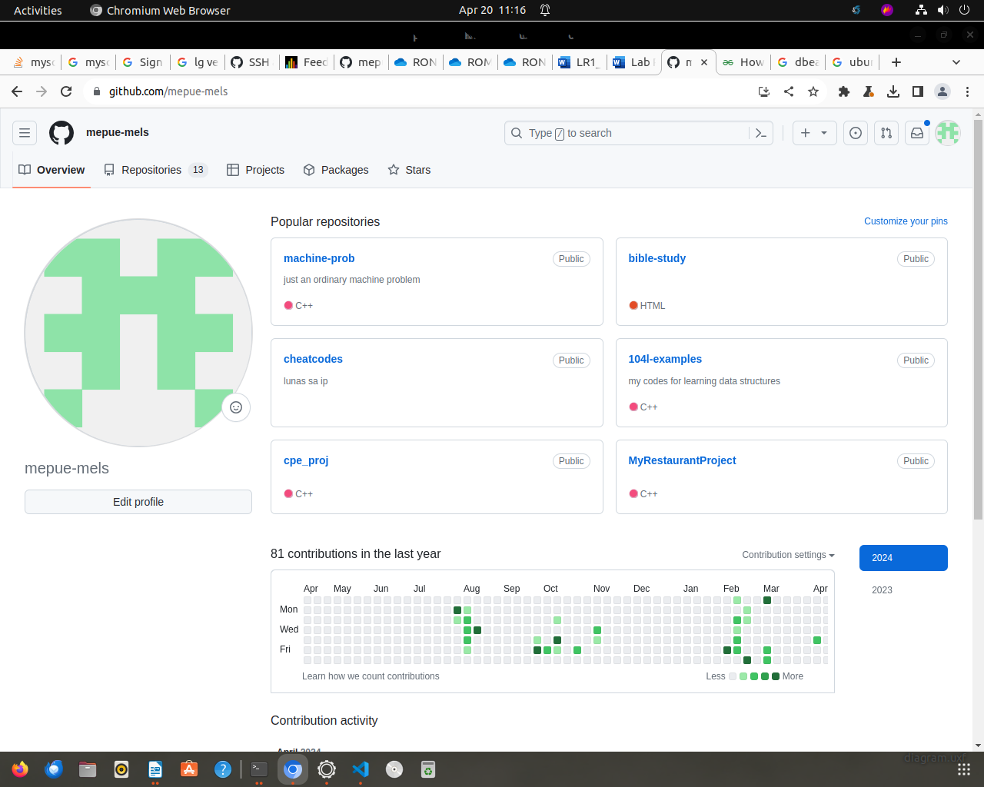

(2) Cloning and setup of GitHub local repository

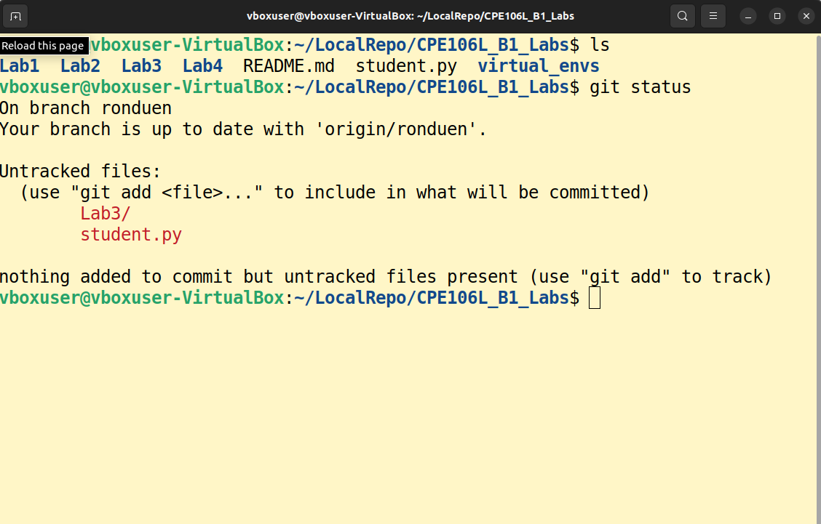

**Part 2:**

**Introduction to Python**

**Note:** Use the sample codes of Lambert’s Chapter 1 in your PreLab. Follow the steps of Chapters 1 and 2.

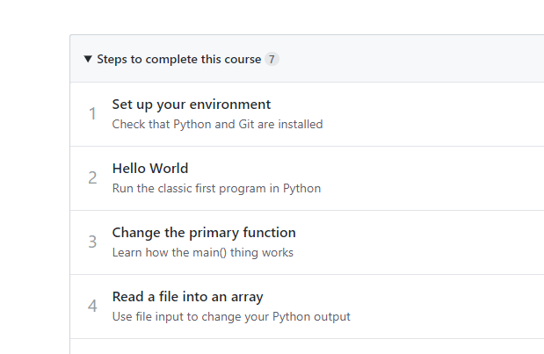

Figure 2. Steps to complete the course ‘Introduction to Python’

1. Follow the Lab Report Template InLab Guide on what to include (i.e. Discussion, Screenshots, etc.)

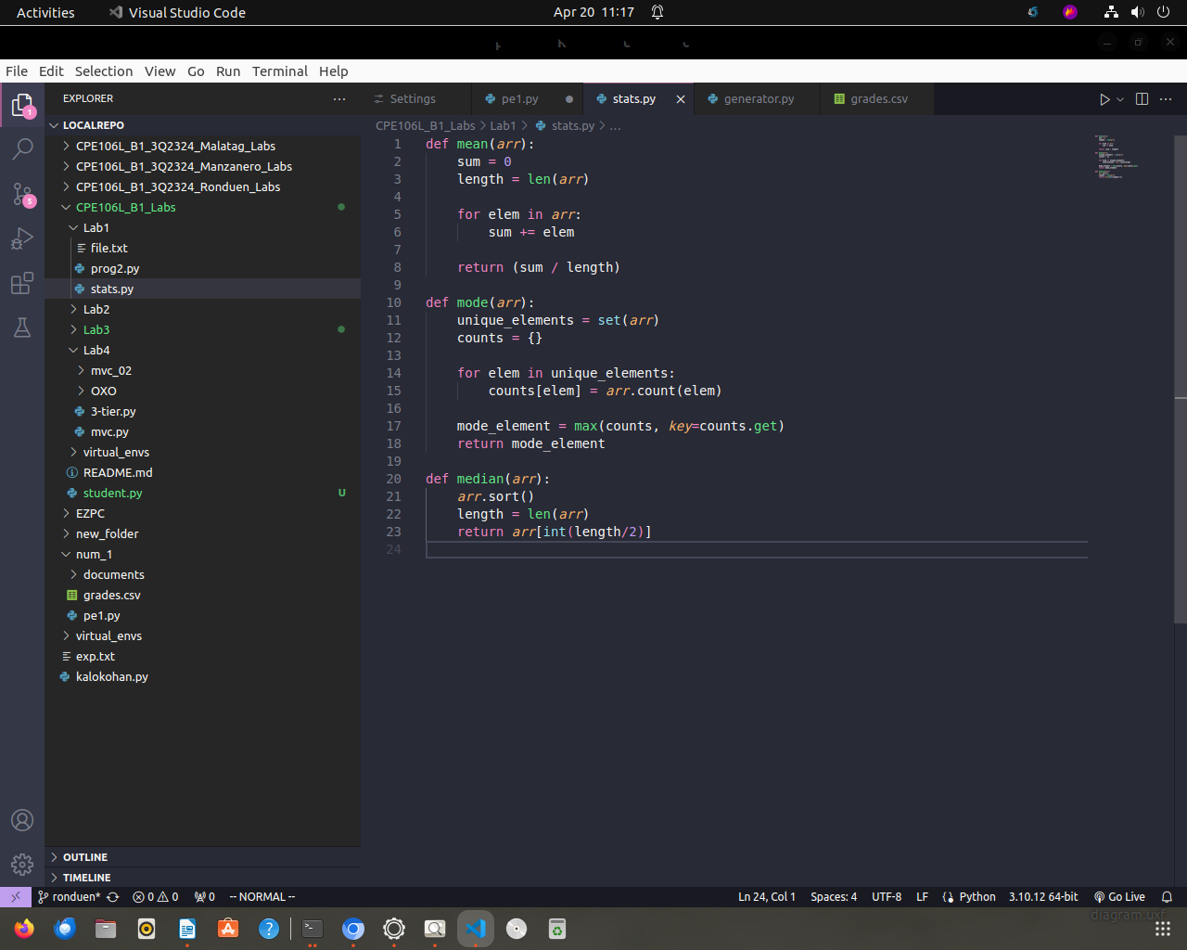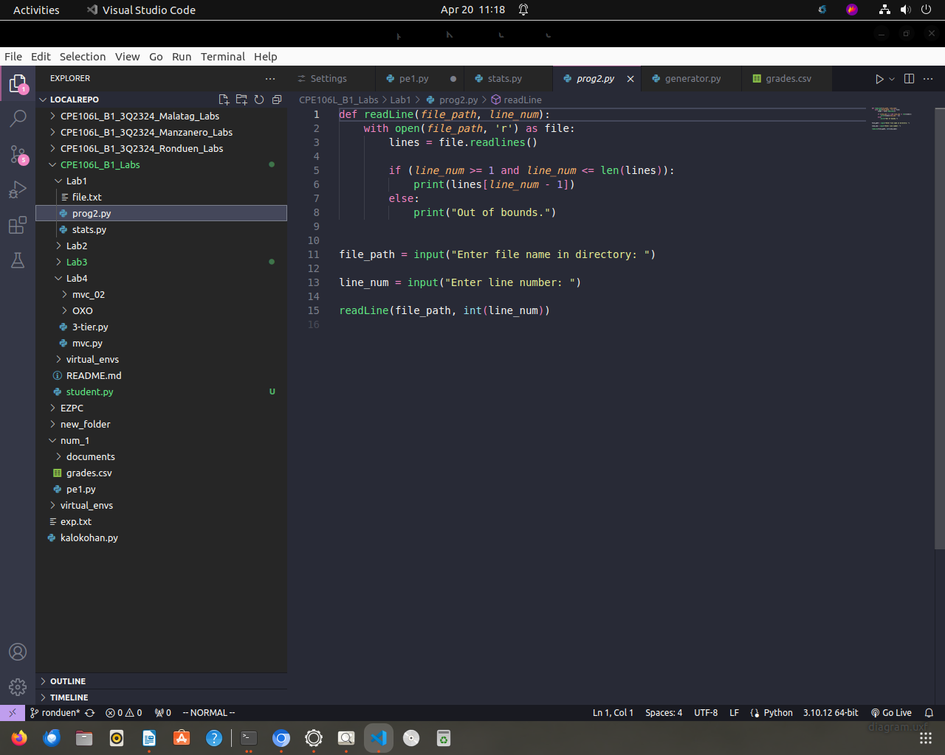

## **PostLab**



**GitHub:** [**https://github.com/mepue-mels/CPE106L_B1_Labs/tree/ronduen**](https://github.com/mepue-mels/CPE106L_B1_Labs/tree/ronduen)

**Programming Problem 1:**

def mean(arr):

sum = 0

length = len(arr)

for elem in arr:

sum += elem

return (sum / length)

def mode(arr):

unique_elements = set(arr)

counts = {}

for elem in unique_elements:

counts[elem] = arr.count(elem)

mode_element = max(counts, key=counts.get)

return mode_element

def median(arr):

arr.sort()

length = len(arr)

return arr[int(length/2)]

**Programming Problem 2:**

def readLine(file_path, line_num):

with open(file_path, 'r') as file:

lines = file.readlines()

if (line_num >= 1 and line_num <= len(lines)):

print(lines[line_num - 1])

else:

print("Out of bounds.")

file_path = input("Enter file name in directory: ")

line_num = input("Enter line number: ")

readLine(file_path, int(line_num))